1. PROJECT ON BIKE BUYER
   1. INTRODUCTION

.

* 1. OBJECTIVE OF RESEARCH

The project consists of deducing the possibility of buying a bike by a customer through machine learning and data analysis techniques. Many customers are lacking their views and even are much more confused about the bike they need to buy. Hence, this is a great strategy to develop how to determine the number of customer buying a bike.

* 1. PROBLEM STATEMENT

To predict if the customer will buy bike or not.

* 1. INDUSTRY PROFILE:-

Modest growth was expected for the bicycle portion of the industry through 2004, due to both economic and demographic factors (including a decline in the number of children in the key 5- to 14-year-old age group). Helping to sustain or increase domestic sales was a U.S. government bill aimed at increasing non-motorized transportation. Approximately $3 billion in funds could be used for building bike paths and other facilities friendly to cyclists. Growth in the motorcycle segment was expected to be somewhat stronger during the same time period. Harley-Davidson and its competitors were ratcheting up production of their popular motorcycles in response to continued strong demand. For example, in 2001, Harley-Davidson invested $290 million to support increased production capabilities. The baby boomer demographic, with increased spending power, continues to fuel a significant amount of growth in the market for large motorcycles.

1. REVIEW OF LITERATURE

***Motorcycles***The motorcycle represented a first step from the bicycle to the automobile. The simple expedient of attaching a gasoline-powered engine to a bicycle frame produced a device that was at once exotic and affordable. During the early 1900s, more than 100 companies began manufacturing motorcycles, including Harley-Davidson, Indian, Orient, Excelsior, Cyclone, Henderson, and Marsh. By 1915, they produced models that could exceed 100 mph. The 1915 Cyclone, designed specifically for racing, could reach speeds of 124 mph but had no throttle and no brakes. Harley-Davidson began production of its first model, the Silent Grey Fellow, in 1903, the same year Henry Ford unveiled the Model A. When Ford introduced his mass-produced Model T in 1913 and sold it for $500, most motorcycle manufacturers could-not competes. After World War I, only Harley-Davidson, Indian, and Excelsior remained. By 1953, only Harley-Davidson remained.

1. DATA COLLECTION

Collected data online from: - <https://catalog.data.gov/dataset?tags=bike>.

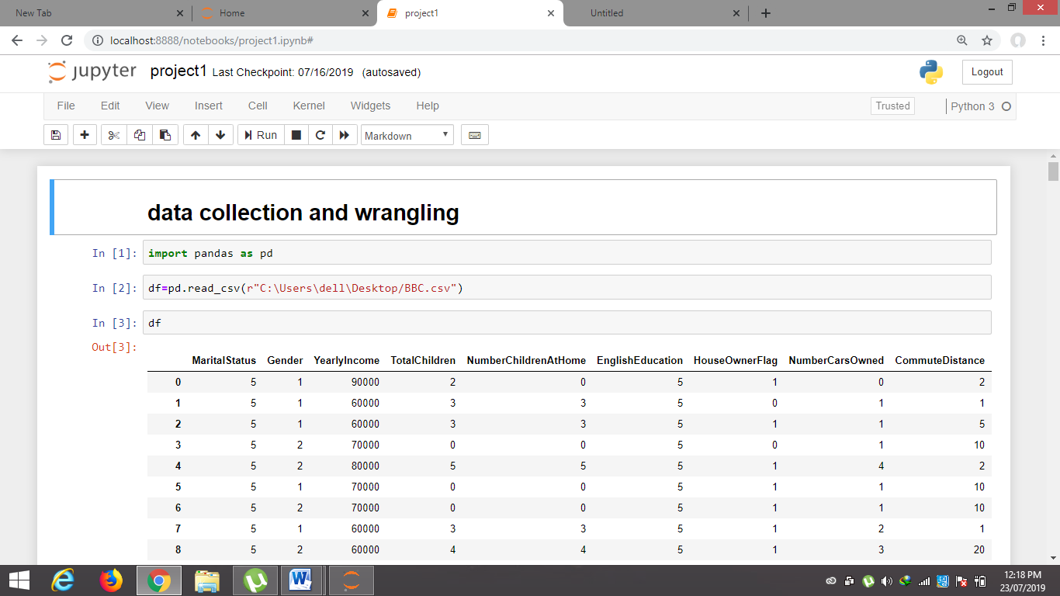

1. METHODOLOGY

4.1. EXPLORATORY DATA ANALYSIS

4.1.1. FIGURES AND TABLES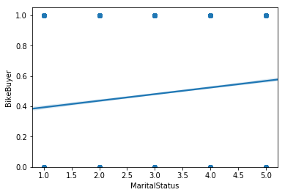

No relationship with martial status.

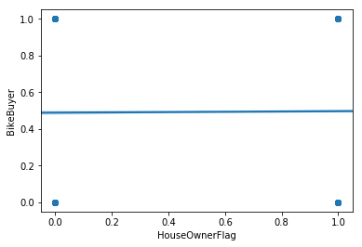

No relationship

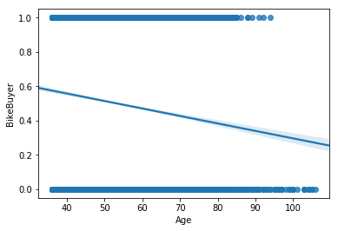

Negative relationship

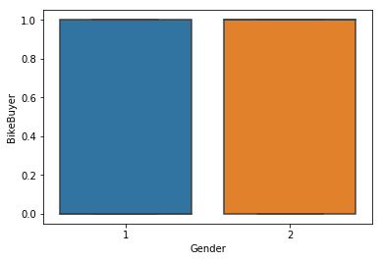

4.2. DATA MODELLING

The model efficiency is 77 percent.

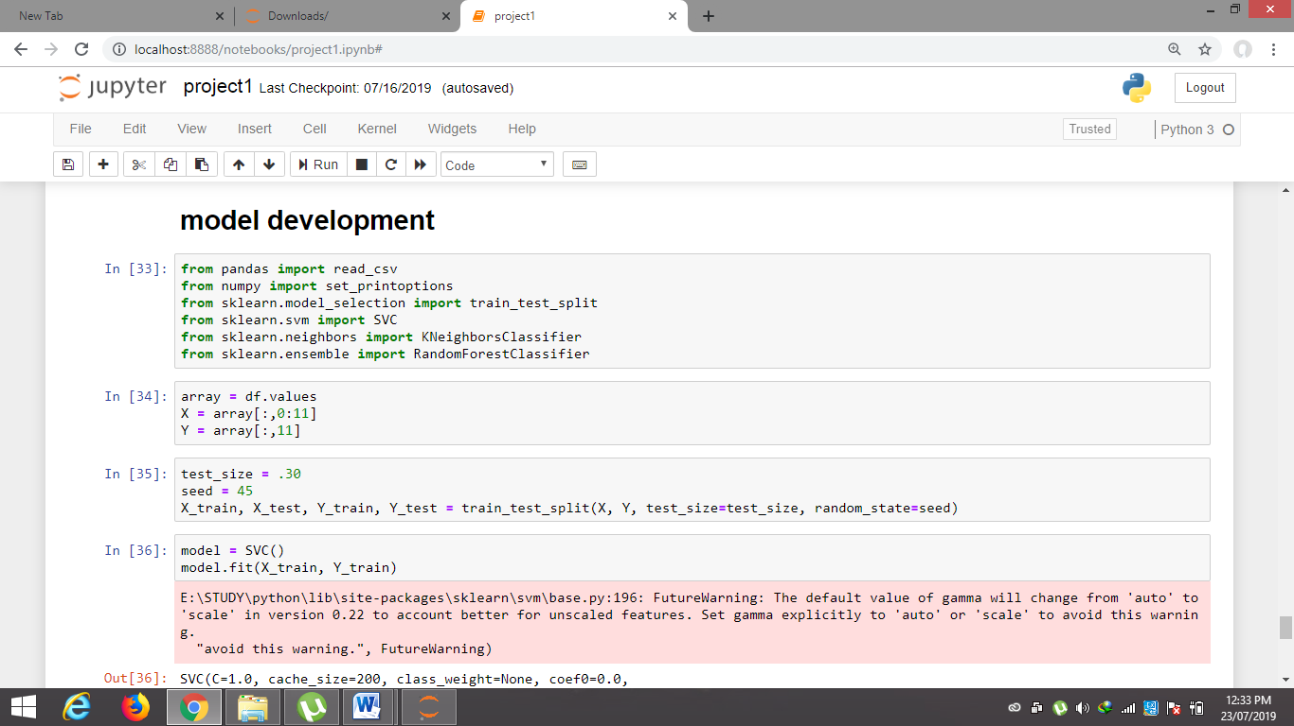

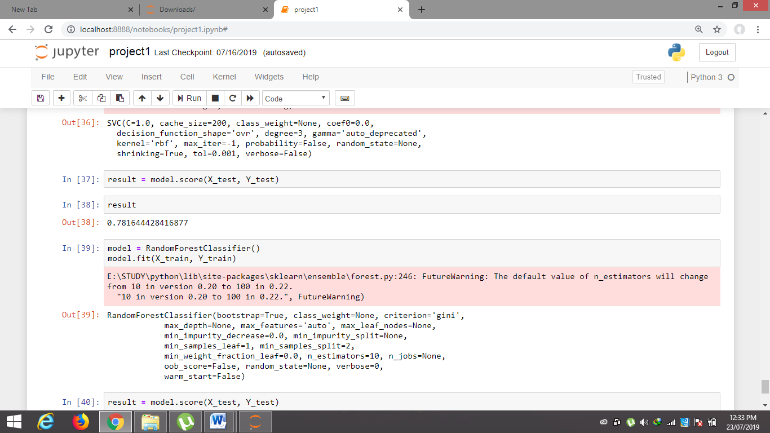

1. CONCLUSION

The model developed for predicting if a person will buy a bike is 77 percent efficient.

1. REFERENCE

Smart bridge modules

Lessons from the sessions.